Marquette Throwdown Men’s Volleyball Tournament
December 1, 2012
Tournament Contacts:
Thomas Niswonger – (262) 510-7065
Nick Manning – (414) 426-8849
Tournament Information:
- Rec Center doors will open at 7:30 AM
- First match begins at 8:30 AM. This document takes place of the captain’s meeting.
- Warmups will be 10 minutes for your first match of the morning (each team has court for 5 minutes) and 6 minutes for every subsequent match (each team has court for 3 minutes)
- We ask our officiating teams to please be on top of things and get to the court you are working and blow the whistle for captains as soon as the previous game has ended. With 20 teams, we would like to keep this tournament moving and on schedule. Reffing teams should deliver score sheets to the concession stand area near court 5 after each match.
- Pool play and playoff matches will be best of three format – 2 games to 25 (cap of 30) and 3rd game to 15 if necessary (cap of 30)
- NCVF rules will govern all play
- Pool rankings will be determined by
  - Match Record
  - Game %
  - Head-to-Head
  - Point Differential
  - Coin Flip
- The top two teams from each pool will move on to the gold bracket and the bottom two will move to the silver bracket.
- Reseeding of all 10 gold teams and all 10 silver teams will occur after pool play in order to seed the brackets. The same ranking method that was used for pool play will be used for this reseeding.
- The top two teams after this reseeding in both the gold and silver bracket will have first round byes in their respective playoff bracket. These teams will ref first round games.
- We will have a concession stand with food and drinks near court 5. Please do not bring in large amounts of outside food and remember to clean up any garbage that you may have.
- Spectators are allowed in the Rec Center but seating is limited. They are welcome to bring in their own seating.
- There will be a trainer on site all day in the hallway outside the gym entrance.
Please remember:
- It is a privilege for us to be able to use these facilities. Clean up after yourselves so we can continue to host this great event in the future.
- Our volleyballs are just that - “ours” - so please respect the fact that our club members work hard to pay for them and leave them at their respective courts when play is finished.

Map of Rec Center and Parking

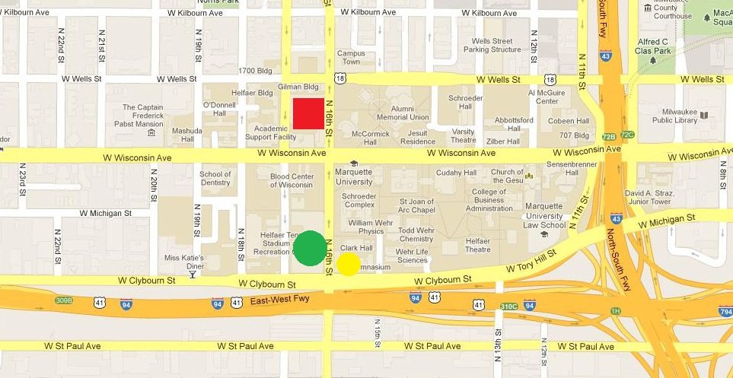

The Helfaer Rec Center is shown as the green dot on the map above. It is located on the corner of 16th Street and Clybourn St. Courts 1-5 are in this gym and the entrance is on 16th street.
The Old Gym court is located just across the street from the Rec Center and is shown by the yellow dot in the map above.
Parking is available in the 16th Street structure shown with the red box just north of Wisconsin Avenue. The entrance to this structure is on 16th Street.
Pools and Schedule
 | Pool A (Court 5) | Pool B (Court 4) | Pool C (Court 2) | Pool D (Court 1) | Pool E (Old Gym)
1 | Team Core | Illinois | Guapo | UW-Oshkosh | UW-Milwaukee
2 | Marquette | West Allis | Lakeland | Buckley | Ball State
3 | Minnesota | UW-Oshkosh 2 | UW-Plateville | Loyola | Marquette 2
4 | Northwestern | Carthage | Butler | Augustana | Anderson

Pool Play Schedule
Time | Game | Ref
8:30 | 1 vs. 3 | 2
9:30 | 2 vs. 4 | 3
10:30 | 2 vs. 3 | 4
11:30 | 1 vs. 4 | 3
12:30 | 1 vs. 2 | 4
1:30 | 3 vs. 4 | 1

Gold Bracket
 |  | #1
#9 |  |  | G5 - (loser:G3)
 | G1 - (#1) |  | Ct. 5 - 4:30
#8 | Ct. 5 - 2:30 |  |  |  | G7 - (loser:G5)
 |  | #4 |  |  | Ct. 5 - 5:30
 |  |  | G3 - (loser:G1)
 |  | #5 | Ct. 5 - 3:30
 |  |  |  |  |  |  | G9 - (loser:G8)
 |  | #2 |  |  |  |  | Ct. 5 - 6:30
#10 |  |  | G6 - (loser:G4)
 | G2 - (#2) |  | Ct. 4 - 4:30
#7 | Ct. 4 - 2:30 |  |  |  | G8 - (loser:G6)
 |  | #3 |  |  | Ct. 4 - 5:30
 |  |  | G4 - (loser:G2)
 |  | #6 | Ct. 4 - 3:30

**Team in parentheses is reffing team

Silver Bracket

 |  | #1
#9 |  |  | S5 - (loser:S3)
 | S1 - (#1) |  | Ct. 1 - 4:30
#8 | Ct. 1 - 2:30 |  |  |  | S7 - (loser:S5)
 |  | #4 |  |  | Ct. 1 - 5:30
 |  |  | S3 - (loser:S1)
 |  | #5 | Ct. 1 - 3:30
 |  |  |  |  |  |  | S9 - (loser:S8)
 |  | #2 |  |  |  |  | Ct. 1 - 6:30
#10 |  |  | S6 - (loser:S4)
 | S2 - (#2) |  | Ct. 2 - 4:30
#7 | Ct. 2 2:30 |  |  |  | S8 - (loser:S6)
 |  | #3 |  |  | Ct. 2 - 5:30
 |  |  | S4 - (loser:S2)
 |  | #6 | Ct. 2 - 3:30

**Team in parentheses is reffing team

